Chapter IX

Focus on OOP, Encapsulation

Chapter IX Topics

9.1 Introduction
9.2 Creating a New Class
9.3 Restricting Attribute Access
9.4 "Get" and "Set" Methods
9.5 Constructor Methods
9.6 The Cube Class Case Study
9.7 The Consequences of Scope
9.8 Method Summary
9.1 Introduction

Object Oriented Programming will not be casually mentioned in this chapter. OOP is the front-center topic right now and the intention is to cover some very important OOP ground. Right now you have a variety of basic Java tools under your belt and you are ready to learn about this very fascinating, modern approach to programming.

Now keep in mind that the single most important goal for any program is reliability. Speed is great; user-friendly is requested, cheap is desirable, but nothing matters if the software does not work properly. First and foremost a program, or program module, must perform its intended task correctly, the first time, the last time and every time in between. There used to be a time in the early days of programming that the simplicity of the programs and the genius of the computer scientists kept reliability pretty much afloat with hard work and an organized approach to programming. In particular, programming became popular by dividing a program into manageable blocks, and concentrating on completing and testing the smaller blocks. Names like structured programming, modular programming, procedural programming, became important buzzwords and programming tools.

Keep in mind that early programs only produced text output. You should know text output, because many program examples have produced text output so far. With the arrival of the Graphical User Interface (GUI) the world of programming changed dramatically, and program complexity has been growing exponentially ever since. A new style of programming came on the scene slowly, at first, but rapidly gained momentum and brought about a whole new way of thinking about programming. Now it matters little if impressive vocabulary is tossed around. The bottom line is still reliability, and as you gain more computer science knowledge you will clearly see how Object Oriented Programming in general and Java in particular do an outstanding job to make programs more reliable.

In an earlier chapter you were told that the three corner stones of OOP are encapsulation, class interaction, and polymorphism. Some brief introduction to encapsulation happened earlier during the previous two chapters. This chapter will continue to explore encapsulation and pick up the pace dramatically.

Programs involve data and the modules that access and process the data. The problem in the past has been that the data and the modules processing the data, called procedures and functions, were separated. This approach caused serious reliability problems. As programs grew in size so did the likelihood that some procedure or function accessed data unintentionally and made unwanted and often disastrous changes to data values. A new style of thinking helped prevent these kinds of problems. This style of thinking revolves around objects. Objects store data and objects also store the modules - called methods in Java - which process the data. So far the object seems no different from programs that combine data storage and procedures that process the stored data. What makes objects unique is that every object has its own set of methods, which are dedicated to the object and the object stores the data that is appropriate for the object. Furthermore, special precautions are designed into the object to insure that data is properly initialized and accessed. As a matter of fact, a proper object will not allow anything outside the object to access its data directly for fear of potential problems. A well-designed object carries its own methods that safely handle the object data.

So what does this all mean? This means you have encapsulation, which is a fancy, but very appropriate word. The data and the methods that act upon the data are all contained in one package or capsule, called an object. Multiple objects can be created for multiple purposes. You can also think of this package as a capsule, a container, and hence the word encapsulation.

Now we must get clear on the vocabulary used with objects. You have heard talk about actions, subroutines, processes, procedures, functions, and methods. All these words have been used intentionally, because you will probably find every term used somewhere in computer science. Each one of these words implies some program module that performs a task, frequently involving data, but not always. However, some task is always involved that must be accomplished.

Life would be simpler if computer scientists could just make up their minds about the naming of these program modules. FORTRAN and BASIC started with subroutines, Pascal followed by having both procedures and functions, and C++ wanted every module to be called a function. You will be pleased to know that the current fashion is to use the word method, and Java error messages will be using that terminology. From here on, method will be used. Keep the following object vocabulary in mind.

Objects, Variables and Methods
Java encapsulates data and action modules that access
the data in one container, called an object.

Object members that perform some task are called methods.

Object members that store data are called attributes.

9.2 Creating a New Class

Java uses many containers. There are classes, methods, loop control structures and selection control structures. Containers have a heading followed by a set of braces { } , which indicate the start and the end of the container.

This chapter is the first focus on Object Orient Programming (OOP) and this first focus is on encapsulation. The introduction stated that the goal of encapsulation is to encapsulate data and all the methods that access the data in the same container or capsule. This capsule in Java is officially called a class.

It has been stated in earlier chapters that a class is a toolkit and a method is a tool. Now it is does not matter if a class is called a container, a capsule, or a toolkit, because the creation of a class will need to start by first creating a container, a capsule or a toolkit. A case study follows that will start very simply and steadily increase in complexity as the class become more and more complete.

There are two case studies formats. The first type presents a completed program. An execution of the completed program is demonstrated followed by an investigation of every component in the program. Explanations are given about the design of the program and the decisions that were made to arrive at a final solution that is presented.

The second style of case study starts with a minimal program. Step after small step, the program grows and an explanation is given with each small improvement along the way. There are good arguments for each style of case study and those arguments are not significant right now. The Card case study that follows will use the second case study style.

Program Java0901.java, in figure 9.1, brings little excitement, but it sets the stage. The main method instantiates a Card object, but nothing can be done with this object. However, the program compiles and creates a simple skeleton for the start of our case study.

Note how the Card class is not declared public. Only one class can be declared public and that is the class with the same name as the file name. Proper program design suggests that each class resides in its own file. In this textbook, and especially with case studies, multiple classes are frequently combined in one file for clarity. Our main focus is on the development of the Card class, but this growing class needs to be tested at each stage by an outside “runner” or “tester” class that creates an object of the Card class.

Figure 9.1
// Java0901.java
// Card Case Study #01
// This shows a minimal class declaration.
// This class has no practical value, but it compiles and executes.
public class Java0901
{
public static void main(String[ ] args)
{
Card card = new Card();
}
}
class Card
{
}



9.3 Restricting Attribute Access

What type of data needs to be stored in a Card class? In this case study there will be three attributes. The first attribute, suit, stores the suit name of the Card object, like clubs, diamonds, hearts and spades. The second data field or attribute is rank, which stores the rank name of the Card object, two, six, ten, Queen, and Ace. The third data field stores the pointValue of the Card object. At first, it may appear that both the rank and pointValue attributes store the same value. Sometimes that is true. The four of clubs has rank four and pointValue 4. Not exactly the same if you consider data types, but certainly they are very similar. Now the Queen of Spades and the King of Spades have rank Queen and King, which is different, but they both have the same pointValue 10 in the game of BlackJack. The same is true for many other card games.This means that rank will be the same for all games, but pointValue depends on the card game.
Program Java0902.java in figure 9.2 adds these data attributes, but nothing is done yet besides placing the attributes in the correct class location. Right now there is not any type of data access at this stage or any visible program output.

Figure 9.2
public class Java0902
{
public static void main(String[ ] args)
{
Card card = new Card();
}
}
class Card
{
String suit; // Clubs, Diamonds, Hearts, Spades
String rank; // Number, Jack, Queen, King, Ace
int pointValue; // Number, 10 for picture, 11 for Ace
}

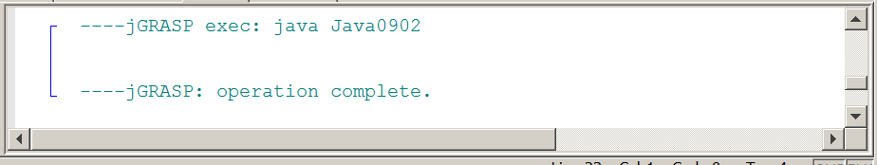

Simple data types store single values. This may a single integer, a single character, a single decimal number or a single boolean. It is not necessary to indicate which member of the variable is being used. There is only one member. It is not an issue. You learned with the Math class that both the class identifier and the method or attribute identifier must the used, like Math.sqrt(100) or Math.PI. If object methods are members of a class then an object must be constructed and the object name is used with the method identifier, like tom.makeDeposit(next). In this case tom is an object of the Bank class.

Using this same data access approach, this means that if card is an object of the Card class, and suit is a field identifier in the class, then you would use syntax like card.suit to access a field inside the object.

This is precisely what is done by program Java0903.java in figure 9.3. First, values are assigned to the three Card data fields and then those values are displayed. You will find that the program compiles just nicely and it also gives the desired, correct output, which right now is blank.

Figure 9.3
// Java0903.java
// Card Case Study #03
// <Card> attributes are accessed directly by the <main> method.
// This program violates encapsulation, even though it compiles, and executes.
// This approach greatly compromises program reliability.
public class Java0903
{
public static void main(String[ ] args)
{
Card card = new Card();
card.suit = "Hearts";
card.rank = "King";
card.pointValue = 10;
System.out.println("Suit: " + card.suit);
System.out.println("Rank: " + card.rank);
System.out.println("Value: " + card.pointValue);
}
}

class Card
{
String suit; // Clubs, Diamonds, Hearts, Spades
String rank; // Number, Jack, Queen, King, Ace
int pointValue; // Number, 10 for picture, 11 for Ace
}



Compiling and nice output are lovely, but it is not sufficient. We committed a serious offense and the OOP Police will probably give us several tickets. The essence of encapsulation is to package the data and the methods that access the data in one container. However, it is not sufficient to package data and methods together; you also need to insure that only a select number of methods can access the data. Accessing the data directly, from outside the class, is a very serious crime in OOP Land. This type of access can create serious unwanted data access and this will be more likely as programs are larger. The next stage, shown by program Java0904.java, in figure 9.4, shows how to insure against that problem by declaring the data attributes as private.

Figure 9.4
// Java0904.java
// Card Case Study #04
// All the variables in the <Card> class are now declared as private access.
// This prevents improper, public access to the data variables.
public class Java0904
{
public static void main(String[ ] args)
{
Card card = new Card();
card.suit = "Hearts";
card.rank = "King";
card.pointValue = 10;
System.out.println("Suit: " + card.suit);
System.out.println("Rank: " + card.rank);
System.out.println("Value: " + card.pointValue);
}
}
class Card
{
private String suit; // Clubs, Diamonds, Hearts, Spades
private String rank; // Number, Jack, Queen, King, Ace
private int pointValue; // Number, 10 for picture, 11 for Ace
}

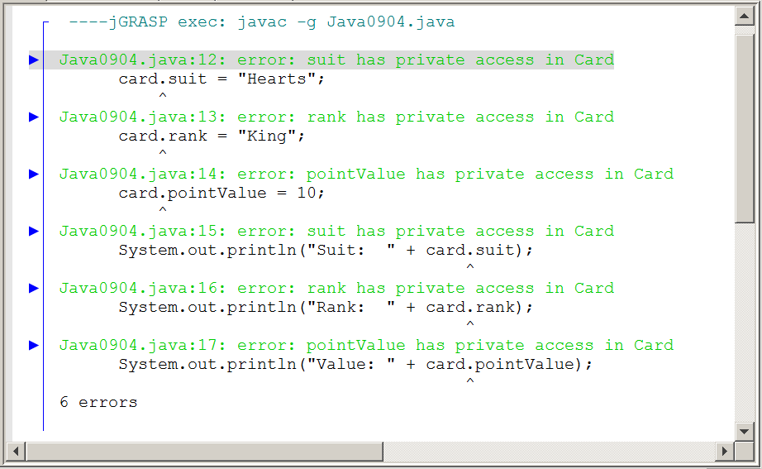
The next section will explain how data can be properly accessed. There may be a few exceptions, but in most cases declare attributes private. You have seen some exception, such as Math.PI and Math.E and in both cases the data fields store constant values that are never meant to change.

Private and Public Members
Members in a class need to be declared as private or public.

Private members can only be accessed by program statements inside the class.

Data attributes usually need to be declared private.

Methods usually need to be declared public.

Public members can be accessed by any program statement, both inside and outside the class.

9.4 "Get" Methods and "Set" Methods

Consider a typical bank. The bank has a lobby that is open to the public. From the lobby, customers can go to tellers to make deposits, withdrawals and loan payments. There are also lobby offices where bank officers take loan applications, handle investments and handle customer concerns. Every area that is mentioned is open to the public.

The bank also has areas that are open only to the bank employees. These private areas include the teller area, which contains the cash drawers and containers that store all the daily check deposits. There is the very private bank vault where large deposits of cash are stored and there is also the private bathroom that is meant for bank employees only.

These physical private and public areas may seem a good analogy to the private and public access that is used with the design of a new class. The bank has more and that is not physical, but electronic and it also involves levels of access. Every bank has a web site. The home page of the bank is very public and draws attention to the many services available to the existing customers or potentially new customers. At this area different bank accounts are explained, as well as available loans and credit cards.

Existing customers can go further and enter a private access personal account. Once proper user id and password are entered, a customer can see bank account transactions, pay bills, make transfers and apply for a loan or credit card. Perhaps it is in this area that we truly see the virtue of private access. All bank accounts have private access. It does not make any sense to let the general public have access to all the many customer bank accounts.

If private access is restricted then it has no practical value. The whole point in combining public local methods with private local attributes is to control data access. In the case of a bank the entry of a UserID and a Password gain access. Frequently, access is even stricter to protect possible fraud and customers are shown a special picture or phrase that insures a customer that the proper bank web site is in fact being used.

Access to a customer's account is not limited to the customer. A teller can look at the account to determine if the balance is large enough for the requested withdrawal. A bank officer uses access to both the private account of the bank itself and a customer to transfer money from the bank account to the customer account after a loan is approved. In every example stated you see the private attribute, a bank account, and an accessing method, like the bank teller or bank officer, which handles the private account in a proper manner to insure reliability and proper privacy.

Program Java0905.java, in figure 9.5, shows the next stage of the Card class, which will include three methods to return the values of the three data attributes. These three methods get information for some other program segment in a class outside the Card class.

By convention such methods are called "get methods" and frequently get is part of the method identifier. In the Bank class program examples you may see methods getCheckingBalance, getSavingsBalance, getCreditScore and others.

Program Java0906.java, in figure 9.6, is identical to the previous program except for the method names change to make all three methods get methods.

Figure 9.5
// Java0905.java
// Card Case Study #05
// The <Card> class now has three methods to return
// the data values of <Card> class objects.
// Note that Java assigns initial values to object data.
public class Java0905
{
public static void main(String[ ] args)
{
Card card = new Card();
System.out.println("Suit: " + card.suit());
System.out.println("Rank: " + card.rank());
System.out.println("Value: " + card.pointValue());
}
}
class Card
{
private String suit;
private String rank;
private int pointValue;
public String suit()
{
return suit;
}
public String rank()
{
return rank;
}
public int pointValue()
{
return pointValue;
}
}

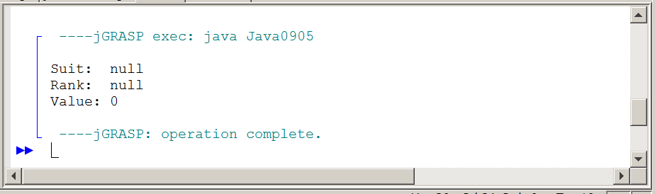
Figure 9.6
// Java0906.java
// Card Case Study #06
// This program is identical to Java0905.java.
// The names of the return methods are changed.
// It is a common convention to call methods that return attribute values "get" methods.
public class Java0906
{
public static void main(String[ ] args)
{
Card card = new Card();
System.out.println("Suit: " + card.getSuit());
System.out.println("Rank: " + card.getRank());
System.out.println("Value: " + card.getPointValue());
}
}
class Card
{
private String suit;
private String rank;
private int pointValue;
public String getSuit()
{
return suit;
}
public String getRank()
{
return rank;
}
public int getPointValue()
{
return pointValue;
}
}

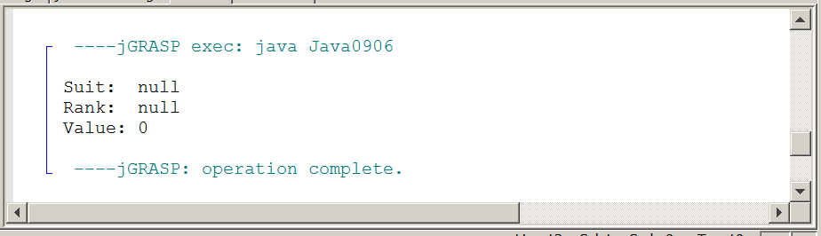
There is something curious about the output of the stage 06. There are three methods used to return the values stored by the Card object, but there is no evidence that any values were ever stored to any of these four data fields. This is intentional. It shows that Java assigns default values when a new object is instantiated. Any of the int variables is assigned value 0.

Zero or 0 makes perfect sense, but what is null for suite or rank? A confession must be made here. Java has an interesting data type, called String. It is possible to create String variables and use String variables as if they were simple data types just like int and boolean. The reality is that String is a class, complete with its own set of methods. null is not the same thing as zero. Zero is a value. We state that water freezes at 0 degrees Celsius. On the other hand, null means no value. Any object that is not assigned an initial value will return value null.

Altering the values of object instance variables is the job of set methods. These methods are parameter methods that normally change the value of a single attribute. Like the get methods, set methods frequently use the word set in the method identifier like, setSuit. Program Java0907.java, in figure 9.7, shows the improved Card class with three segments. There are data attributes, get methods and set methods.

By convention many programmers use complete, self-commenting identifiers for the data fields of the class and then use abbreviations of those names as the formal parameters in the headings of the methods.

You will also note that the set methods and the earlier get methods are now shown in a compact style where each method is written on one line. This style saves space and it is often done for short methods that only have one program statement.

Figure 9.7
// Java0907.java
// Card Case Study #07
// The <Card> class adds "set" methods to alter the data attributes of <Card> objects.
public class Java0907
{
public static void main(String[ ] args)
{
Card card = new Card();
card.setSuit("Clubs");
card.setRank("Seven");
card.setPointValue(7);
System.out.println("Suit: " + card.getSuit());
System.out.println("Rank: " + card.getRank());
System.out.println("Value: " + card.getPointValue());
}
}
class Card
{
private String suit;
private String rank;
private int pointValue;
public String getSuit() { return suit; }
public String getRank() { return rank; }
public int getPointValue() { return pointValue; }
public void setSuit(String s) { suit = s; }
public void setRank(String r) { rank = r; }
public void setPointValue(int pV) { pointValue = pV; }
}

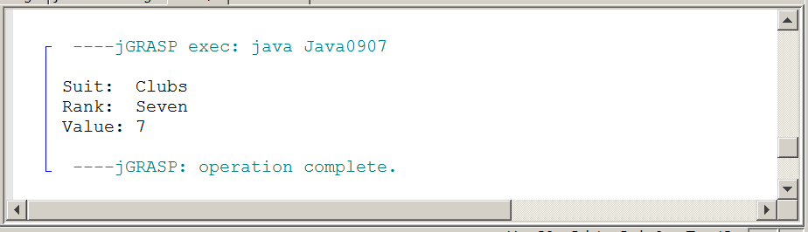

9.5 Constructor Methods

It is easier to demonstrate the creation of get methods and set methods first, but in the real world of designing classes and writing programs, you need to create the constructor methods after the data is selected. The primary job of the constructor is to initialize the attributes of an object. The constructor is automatically called by the new operator and increases reliability by assigning correct starting values to the data. Program Java0908.java, in figure 9.8, shows the improvement created by adding a constructor to the program.

Figure 9.8
// Java0908.java
// Card Case Study #08
// This <Card> class uses a constructor to initialize variables
// during the instantiation of a new <Card> object.
// This is an example of increasing reliability by an automatic constructor call.
public class Java0908
{
public static void main(String[ ] args)
{
Card card = new Card();
System.out.println("Suit: " + card.getSuit());
System.out.println("Rank: " + card.getRank());
System.out.println("Value: " + card.getPointValue());
}
}
class Card
{
private String suit;
private String rank;
private int pointValue;
public Card()
{
suit = "Clubs";
rank = "Two";
pointValue = 2;
}
public String getSuit() { return suit; }
public String getRank() { return rank; }
public int getPointValue() { return pointValue; }
}

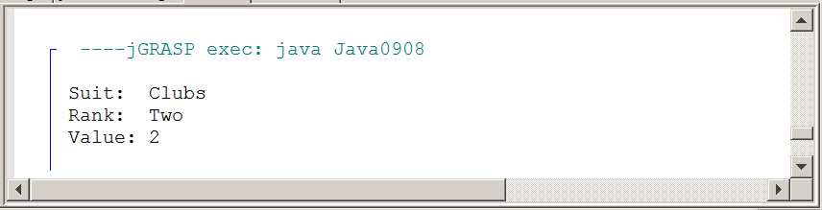
Every Card object starts its life the same boring way with the same initial values for its three data attributes. It is allowed, and strongly encouraged, to create multiple constructors in a class. You have a default constructor, which is good when no parameters are specified for the new object. After the default constructor you can declare extra constructors for a variety of different situations. In the next program a Card object is constructed with specified values for suit, rank and pointValue. Program Java0909.java, in figure 9.9, shows the two constructors in one class.

Figure 9.9
// Java0909.java
// Card Case Study #09
// A second, overloaded constructor, method is added to the program.
// It is now possible to specify Card object details during instantiation.
public class Java0909
{
public static void main(String[ ] args)
{
Card card = new Card("Diamonds","Queen",10);
System.out.println("Suit: " + card.getSuit());
System.out.println("Rank: " + card.getRank());
System.out.println("Value: " + card.getPointValue());
}
}
class Card
{
private String suit;
private String rank;
private int pointValue;
public Card()
{
suit = "Clubs";
rank = "Two";
pointValue = 2;
}
public Card(String s, String r, int pV)
{
suit = s;
rank = r;
pointValue = pV;
}

public String getSuit() { return suit; }
public String getRank() { return rank; }
public int getPointValue() { return pointValue; }
}

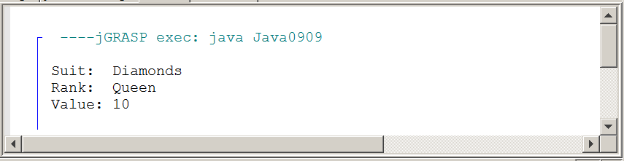

Instantiation and Construction
A class is a template that can form many objects.
An object is a single variable instance of a class.
Objects are sometimes called instances.

An object is created with the new operator. The creation
of a new object is called:
instantiation of an object or construction of an object

The special method that is called during the instantiation of
an object is called a constructor.

Constructor Method Notes
Constructors are methods, which are called during the
instantiation of an object with the new operator.
The primary purpose of a constructor is to initialize all the
attributes of newly created object.

Constructors have the same identifier as the class.
Constructors are neither void methods nor return methods.
Constructors can be overloaded methods.

9.6 The Cube Class Case Study

The title of this textbook is Exposure Java. The content of this chapter is so significant that you will get more than your share of exposure. You will be pleased to know that this chapter has a second case study. The intention is that you have a solid OOP foundation in the area of encapsulation when you leave this chapter. The second case study involves manipulation of a cube. A cube is a three-dimensional object and it may be useful to have a special class to assist with some graphics programs that require displaying cubes.

Cube Case Study, Stage #1

Program Java0910.java, in figure 9.10, starts with a small Cube class. This program does not have any output yet. The class has a constructor, which initializes the top-left coordinate of the cube. If you execute the program, you will see an applet window, but the window lacks excitement. Nothing will show.

Figure 9.10
// Java0910.java
// Cube Casestudy #1
// Stage #1 presents a <Cube> class with a default constructor.
// This program does not display a cube yet.

import java.awt.*;
import java.applet.*;

public class Java0910 extends Applet
{
public void paint(Graphics g)
{
Cube cube = new Cube(g);
}
}

class Cube
{
private int tlX; // topleft X coordinate of the Cube's position
private int tlY; // topleft y coordinate of the Cube's position

public Cube(Graphics g)
{
tlX = 50;
tlY = 50;
}
}

Cube Case Study, Stage #2

The constructor initializes the starting coordinates of a cube objects at [50,50]. Is there any magic in those numbers? No, there is not, but some values need to be selected and [50,50] will do nicely. Program Java0911.java, in figure 9.11, alters the constructor and includes a call to the new draw method. Method draw draws a cube at the current value of tlX and tlY. The result is a single cube.

Figure 9.11
// Java0911.java
// Cube Casestudy #2
// Stage #2 adds a <draw> method to display one cube object.

import java.awt.*;
import java.applet.*;

public class Java0911 extends Applet
{
public void paint(Graphics g)
{
Cube cube = new Cube(g);
cube.draw(g);
}
}

class Cube
{
private int tlX; // topleft X coordinate of the Cube's position
private int tlY; // topleft y coordinate of the Cube's position

public Cube(Graphics g)
{
tlX = 50;
tlY = 50;
}

public void draw(Graphics g)
{
int tlX2 = tlX + 12;
int tlY2 = tlY + 12;
g.setColor(Color.black);
g.drawRect(tlX,tlY,50,50);
g.drawRect(tlX2,tlY2,50,50);
g.drawLine(tlX,tlY,tlX2,tlY2);
g.drawLine(tlX+50,tlY,tlX2+50,tlY2);
g.drawLine(tlX,tlY+50,tlX2,tlY2+50);
g.drawLine(tlX+50,tlY+50,tlX2+50,tlY2+50);
}
}

Figure 9.11 Continued
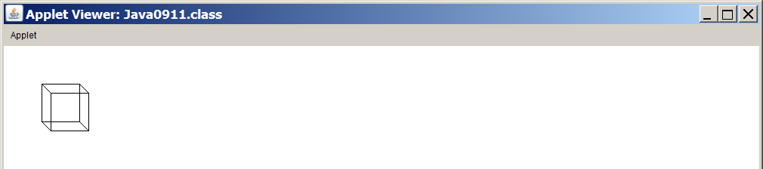

Cube Case Study, Stage #3

Program Java0912.java, in figure 9.12, adds a second constructor, which can specify the initial coordinate values of the cube object as well as its size. This third stage is not only a matter of adding a second constructor. The draw method now has issues. It has many 50s throughout because every cube it draws is 50 pixels wide and 50 pixels tall. The solution is a new improved draw method capable of drawing cubes not only at any location, but also any size.

Figure 9.12
// Java0912.java  // Cube Casestudy #3  // Stage #3 adds a 2nd, overloaded  // constructor to specify the size and  // the location of the cube.  // The <draw> method handles  // different cube sizes.  import java.awt.*;  import java.applet.*;  public class Java0912 extends Applet  {  public void paint(Graphics g)  {  Cube cube1 =  new Cube(g,50,50,50);  cube1.draw(g);  Cube cube2 = new Cube(g,400,50,100);  cube2.draw(g);  Cube cube3 =  new Cube(g,50,300,150);  cube3.draw(g);  Cube cube4 =  new Cube(g,400,300,200);  cube4.draw(g);  }  } | class Cube  {  private int tlX;  private int tlY;  private int size;  public Cube(Graphics g)  {  tlX = 50;  tlY = 50;  size = 50;  }  public Cube(Graphics g, int x, int y, int s)  {  tlX = x;  tlY = y;  size = s;  }  public void draw(Graphics g)  {  int tlX2 = tlX + size/3;  int tlY2 = tlY + size/3;  g.setColor(Color.black);  g.drawRect(tlX,tlY,size,size);  g.drawRect(tlX2,tlY2,size,size);  g.drawLine(tlX,tlY,tlX2,tlY2);  g.drawLine(tlX+size,tlY,tlX2+size,tlY2);  g.drawLine(tlX,tlY+size,tlX2,tlY2+size);  g.drawLine(tlX+size,tlY+size,tlX2+size,tlY2+size);  }  }
Figure 9.12 Continued
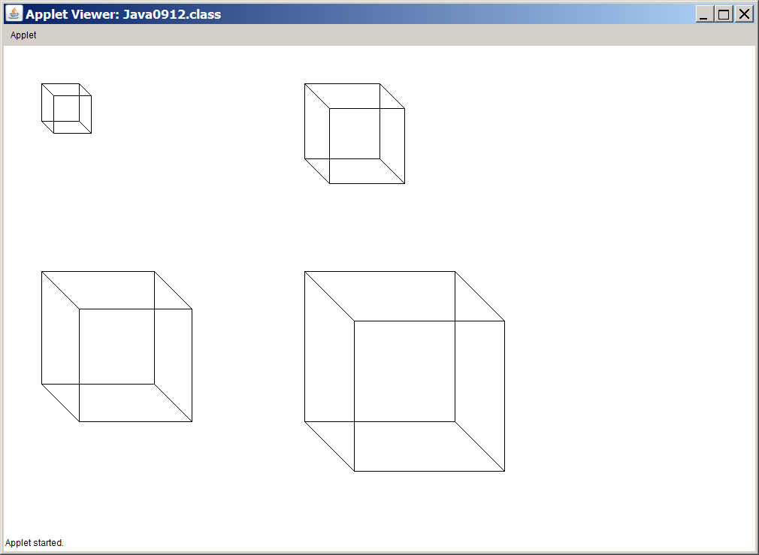

Cube Case Study, Stage #4

Program Java0913.java, in figure 9.13, adds the move method. It is now possible to relocate a cube to a new location after the initial construction, and placement, of the cube object.

Figure 9.13
// Java0913.java
// Cube Casestudy #4
// Stage #4 adds a <move> method, which updates the cube's coordinates
// and draws a cube at the new location.

import java.awt.*;
import java.applet.*;

public class Java0913 extends Applet
{
public void paint(Graphics g)
{
Cube cube = new Cube(g,50,50,50);
for (int x = 50; x < 750; x += 50)
cube.move(g,x,300);
}
}

class Cube
{
private int tlX; // topleft X coordinate of the Cube's position
private int tlY; // topleft y coordinate of the Cube's position
private int size; // the size of the cube along one edge

public Cube(Graphics g)
{
tlX = 50;
tlY = 50;
size = 50;
}

public Cube(Graphics g, int x, int y, int s)
{
tlX = x;
tlY = y;
size = s;
}

public void draw(Graphics g)
{
int tlX2 = tlX + size/3;
int tlY2 = tlY + size/3;
g.setColor(Color.black);
g.drawRect(tlX,tlY,size,size);
g.drawRect(tlX2,tlY2,size,size);
g.drawLine(tlX,tlY,tlX2,tlY2);
g.drawLine(tlX+size,tlY,tlX2+size,tlY2);
g.drawLine(tlX,tlY+size,tlX2,tlY2+size);
g.drawLine(tlX+size,tlY+size,tlX2+size,tlY2+size);
}

public void move(Graphics g, int x, int y)
{
tlX = x;
tlY = y;
draw(g);
}
}

Figure 9.13 Continued
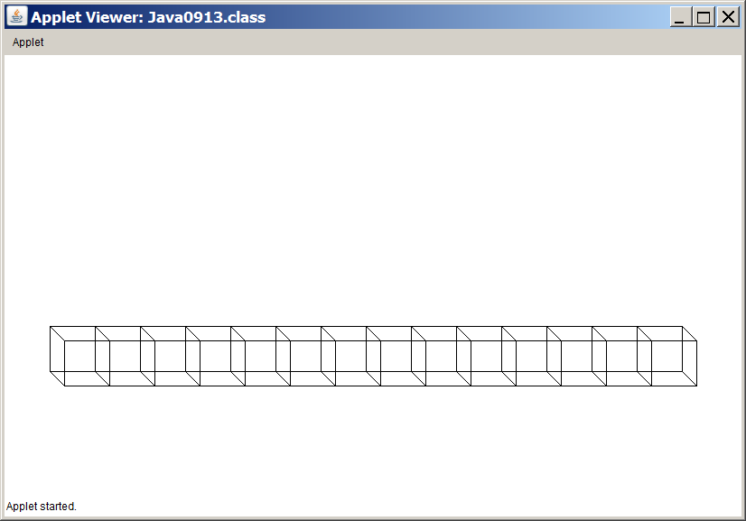

Cube Case Study, Stage #5

Let's see if we can have some fun. Everybody likes animation. Moving objects simply is far more exciting than static objects going no place. Program Java0914.java, in figure 9.14, shows a Cube class with an erase method. The aim is to move the cube to a new location and then erase the cube from the previous location. What you see is a simple introduction to animation. Actually, you see absolutely nothing because the move and erase occur so quickly that the last cube location is erased before you had a chance to see anything.

Figure 9.14
// Java0914.java
// Cube Casestudy #5
// Stage #5 adds an <erase> method, which erases the cube at the current [tlX,tlY] coordinates.
// This program has a problem because the cube object is erased immediately after it is drawn.

import java.awt.*;
import java.applet.*;

public class Java0914 extends Applet
{
public void paint(Graphics g)
{
Cube cube = new Cube(g,50,50,50);
for (int x = 50; x < 750; x += 50)
{
cube.move(g,x,300);
cube.erase(g);
}
}
}

class Cube
{
private int tlX; // topleft X coordinate of the Cube's position
private int tlY; // topleft y coordinate of the Cube's position
private int size; // the size of the cube along one edge

public Cube(Graphics g)
{
tlX = 50;
tlY = 50;
size = 50;
}

public Cube(Graphics g, int x, int y, int s)
{
tlX = x;
tlY = y;
size = s;
}

public void draw(Graphics g)
{
int tlX2 = tlX + size/3;
int tlY2 = tlY + size/3;
g.setColor(Color.black);
g.drawRect(tlX,tlY,size,size);
g.drawRect(tlX2,tlY2,size,size);
g.drawLine(tlX,tlY,tlX2,tlY2);
g.drawLine(tlX+size,tlY,tlX2+size,tlY2);
g.drawLine(tlX,tlY+size,tlX2,tlY2+size);
g.drawLine(tlX+size,tlY+size,tlX2+size,tlY2+size);
}

public void move(Graphics g, int x, int y)
{
tlX = x;
tlY = y;
draw(g);
}

public void erase(Graphics g)
{
int tlX2 = tlX + size/3;
int tlY2 = tlY + size/3;
g.setColor(Color.white);
g.drawRect(tlX,tlY,size,size);
g.drawRect(tlX2,tlY2,size,size);
g.drawLine(tlX,tlY,tlX2,tlY2);
g.drawLine(tlX+size,tlY,tlX2+size,tlY2);
g.drawLine(tlX,tlY+size,tlX2,tlY2+size);
g.drawLine(tlX+size,tlY+size,tlX2+size,tlY2+size);
}
}

Cube Case Study, Stage #6

Our Cube class needs a small, clever method to help with this animation stuff. It is called method delay. Method delay stops program execution for a specified number of milliseconds. It is now possible to slow down the program execution sufficiently to observe some movement with Java0915.java, in figure 9.15.

Figure 9.15
// Java0915.java
// Cube Casestudy #6
// Stage #6 adds a <delay> method which stops program execution for a specified number of
// milli seconds. This makes the cube visible and creates a simple type of animation.

import java.awt.*;
import java.applet.*;

public class Java0915 extends Applet
{
public void paint(Graphics g)
{
Cube cube = new Cube(g,50,50,50);
for (int x = 50; x < 750; x += 20)
{
cube.move(g,x,300);
cube.delay(100);
cube.erase(g);
}
}
}
class Cube
{
private int tlX; // topleft X coordinate of the Cube's position
private int tlY; // topleft y coordinate of the Cube's position
private int size; // the size of the cube along one edge

public Cube(Graphics g)
{
tlX = 50;
tlY = 50;
size = 50;
}

public Cube(Graphics g, int x, int y, int s)
{
tlX = x;
tlY = y;
size = s;
}

public void draw(Graphics g)
{
int tlX2 = tlX + size/3;
int tlY2 = tlY + size/3;
g.setColor(Color.black);
g.drawRect(tlX,tlY,size,size);
g.drawRect(tlX2,tlY2,size,size);
g.drawLine(tlX,tlY,tlX2,tlY2);
g.drawLine(tlX+size,tlY,tlX2+size,tlY2);
g.drawLine(tlX,tlY+size,tlX2,tlY2+size);
g.drawLine(tlX+size,tlY+size,tlX2+size,tlY2+size);
}

public void move(Graphics g, int x, int y)
{
tlX = x;
tlY = y;
draw(g);
}

public void erase(Graphics g)
{
int tlX2 = tlX + size/3;
int tlY2 = tlY + size/3;
g.setColor(Color.white);
g.drawRect(tlX,tlY,size,size);
g.drawRect(tlX2,tlY2,size,size);
g.drawLine(tlX,tlY,tlX2,tlY2);
g.drawLine(tlX+size,tlY,tlX2+size,tlY2);
g.drawLine(tlX,tlY+size,tlX2,tlY2+size);
g.drawLine(tlX+size,tlY+size,tlX2+size,tlY2+size);
}

public void delay(int n)
{
long startDelay = System.currentTimeMillis();
long endDelay = 0;
while (endDelay - startDelay < n)
endDelay = System.currentTimeMillis();
}
}

Make sure that you observe the program execution on a computer. If you look at the textbook page, you will see the cube in one location. The output display captured the cube on its path, but it does move.

This is one reason why it is so important to read the textbook chapters with the Java programs loaded. Observe each execution and more importantly, play with the program code. That is how you really learn to comprehend programming. Make changes. Some changes result in compile errors and this will teach you more about correct Java syntax. Other changes alter the program execution and it will help you understand the logic of programming statements better.

Please realize that computer science cannot be learned with memory. Yes, it has a similarity to learning foreign language. There is vocabulary that must be remembered and yes there are grammar rules that must be understood, but you cannot write a good story in any language based on memory. It is no different with computer science programming.

Figure 9.15 Continued
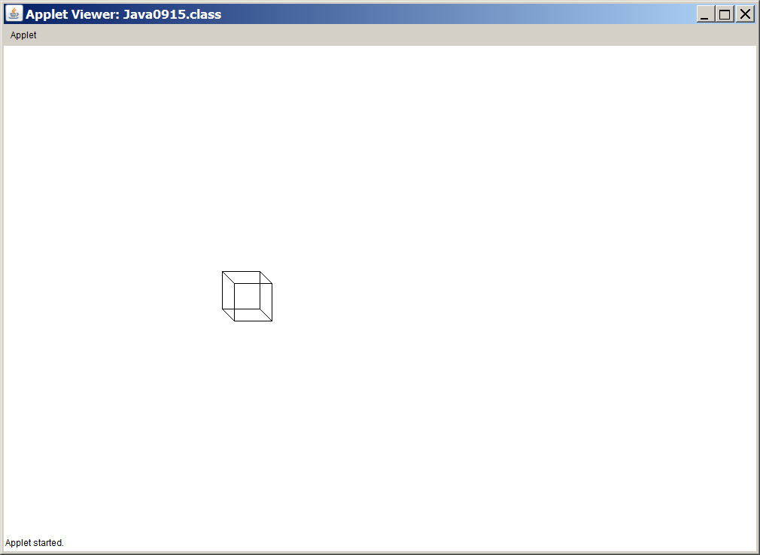

Cube Case Study, Stage #7

Animation is fun, but we need to return to reality. The last stage in this case study is Java0916.java, in figure 9.16. The Cube class adds three important get methods that return the data of the Cube object. In a graphics program this type of information is especially important for debugging purposes when data values need to checked. The program below is not complete.

This program displays a single large cube, but behind the graphics window you will see a text window that displays the data attribute values.

Figure 9.16
// Java0916.java
// Cube Casestudy #7
// Stage #7 adds three get methods that return the instance variable values.
// They are methods <getX>, <getY> and <getSize>.

class Cube
{
private int tlX; // topleft X coordinate of the Cube's position
private int tlY; // topleft y coordinate of the Cube's position
private int size; // the size of the cube along one edge

public int getX()
{
return tlX;
}

public int getY()
{
return tlY;
}

public int getSize()
{
return size;
}
}

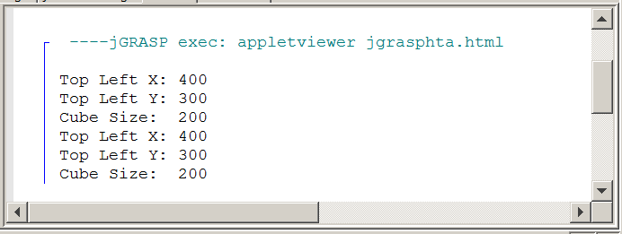

9.7 The Consequences of Scope

The next topic in this chapter may seem to be outside the encapsulation business. Read carefully and play with the program examples. This is not a "pure" OOP topic, but it is important and scope must be understood properly to create correct classes and methods.

Consider program Java0917.java, in figure 9.17. This program defines variable counter twice, followed by a double definition of myAge. The program does not compile. Perhaps you are not surprised, because duplicate definitions are not allowed and yet the error message is only concerned about the duplicate definition of myAge. Apparently Java does not get excited about a double counter. The issue is a matter of understanding scope.

Figure 9.17
// Java0917.java
// This program demonstrates how one variable name <counter> can be
// declared twice correctly.
// It also shows <myAge> declared twice incorrectly.

public class Java0917
{
public static void main(String[ ] args)
{
for (int counter = 1; counter <= 5; counter++)
System.out.print(counter + " ");

for (int counter = 10; counter <= 15; counter++)
System.out.print(counter + " ");

int myAge = 16;
int myAge = 25;
}
}

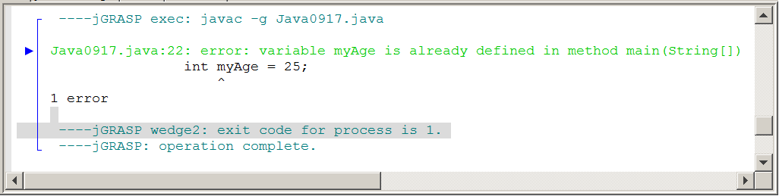
Program Java0918.java, in figure 9.18, is a little strange looking. There are four variables defined in various locations of the file. This program is odd in the practical sense, but created to demonstrate the scope of four different variables.

Figure 9.18
// Java0918.java
// This program demonstrates the scope of a variable.

public class Java0918
{
public static void main(String[ ] args)
{
int var1 = 10;
System.out.println("var1 in main is " + var1);

System.out.print("var2 inside the main method for loop is ");
for (int var2 = 1; var2 < 10; var2++)
{
System.out.print(var2 + " ");
}

System.out.println();
Boo boo = new Boo(var1);
System.out.println("var4 in Boo is " + boo.getData());
}
}

class Boo
{
private int var4;

public Boo(int var3)
{
var4 = var3;
System.out.println("var3 in constructor is " + var3);
}

public int getData() { return var4; }
}

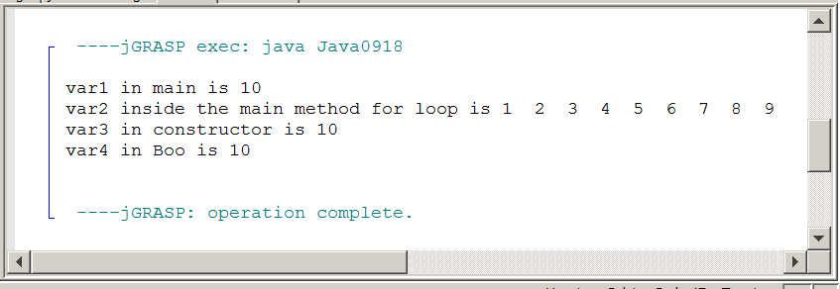
What is scope? The scope of a variable - simple, primitive data type or complex object - is the segment of a program during which a variable is defined, has allocated memory to store values and can be accessed. You can think of scope somewhat like jurisdiction of a police department. Dallas police officers have jurisdiction in the city of Dallas only. The Dallas county sheriff's department has jurisdiction over the entire county of Dallas, which includes the city of Dallas. The Texas state troopers have jurisdiction over the entire state of Texas, which includes Dallas county and the city of Dallas.

Identifier var1, in figure 9.19, is declared in main and has access for the entire main method. Identifier var2, in figure 9.20, is also defined in main, but the scope is limited to the for loop heading and body. Identifier var3, in figure 9.21, has a scope limited to the constructor of Boo and finally, identifier var4, in figure9.22, has scope of the entire Boo class.

Figure 9.19 shows the scope of var1
// Java0918.java
// This program demonstrates the scope of a variable.

public class Java0918
{
public static void main(String[ ] args)
{
int var1 = 10;
System.out.println("var1 in main is " + var1);

System.out.print("var2 inside the main method for loop is ");
for (int var2 = 1; var2 < 10; var2++)
{
System.out.print(var2 + " ");
}

System.out.println();
Boo boo = new Boo(var1);
System.out.println("var4 in Boo is " + boo.getData());
}
}

class Boo
{
private int var4;

public Boo(int var3)
{
var4 = var3;
System.out.println("var3 in constructor is " + var3);
}

public int getData() { return var4; }
}

Figure 9.19 Continued
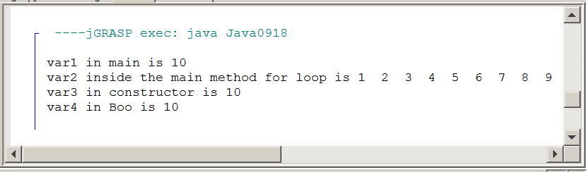

Figure 9.20 shows the scope of var2
// Java0918.java
// This program demonstrates the scope of a variable.

public class Java0918
{
public static void main(String[ ] args)
{
int var1 = 10;
System.out.println("var1 in main is " + var1);

System.out.print("var2 inside the main method for loop is ");
for (int var2 = 1; var2 < 10; var2++)
{
System.out.print(var2 + " ");
}

System.out.println();
Boo boo = new Boo(var1);
System.out.println("var4 in Boo is " + boo.getData());
}
}

class Boo
{
private int var4;

public Boo(int var3)
{
var4 = var3;
System.out.println("var3 in constructor is " + var3);
}

public int getData()
{
return var4;
}
}

Figure 9.21 shows the scope of var3
class Boo
{
private int var4;

public Boo(int var3)
{
var4 = var3;
System.out.println("var3 in constructor is " + var3);
}

public int getData()
{
return var4;
}
}

Figure 9.22 shows the scope of var4
class Boo
{
private int var4;

public Boo(int var3)
{
var4 = var3;
System.out.println("var3 in constructor is " + var3);
}

public int getData()
{
return var4;
}
}

Scope Definition
The scope of a variable - primitive data type or complex object - is the segment of a program during which a variable is defined, has allocated memory to store values and can be accessed.

If two variables have the same identifier and also the same scope, Java will object with a duplicate definition compile error.

There is more to the scope story. There are programmers who like the actual parameters, the formal parameters and any other variables carrying the same value to all have the same identifiers. Java does not object. Making variables throughout a program use the same identifier, if they carry the same value, clarifies the intent of the variable.

This approach can cause a logic error that is shown by Java0919.java, in figure 9.23. When the Widget object w is constructed, value 100 is passed to the constructor. The intent is that the new object will store 100 widgets. The reality is that not a single widget is stored and numWidgets returns an initial default value of 0.

Figure 9.23
// Java0919.java
// This program shows the logic problem that results from using two variables
// with the same name identifier, but two different scopes.

public class Java0919
{
public static void main(String args[])
{
Widget w = new Widget(100);
System.out.println("Object w has " + w.getWidgets() + " widgets");
}
}

class Widget
{
private int numWidgets;

public Widget(int numWidgets)
{
numWidgets = numWidgets;
}

public int getWidgets()
{
return numWidgets;
}
}

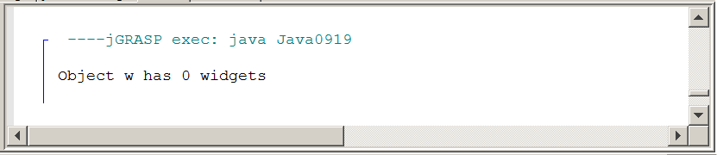
The problem is the highlighted numWidgets = numWidgets statement. This identifier is identical to the Widget private attribute numWidget. There is no compile issue with this approach, because numWidget in the constructor and numWidget as the class attribute have different scope. Java is happy with the syntax. It is great that everybody is fine, but it also means that value 100 does not go anywhere beyond the constructor.

There are two solutions to solve this logic error and do remember that logic errors will never create any type of compile error message or runtime exception indication. Java lets the programmer deal with logic errors. The first solution is shown by Java0920.java, in figure 9.24. Use a different identifier for the formal parameter in the method heading than the attribute identifier. The program output now displays the correct output.

Figure 9.24
// Java0920.java
// Using different variable names is one solution to the
// problem caused by program Java0919.java.

public class Java0920
{
public static void main(String[ ] args)
{
Widget w = new Widget(100);
System.out.println("Object w has " + w.getWidgets() + " widgets");
}
}

class Widget
{
private int numWidgets;

public Widget(int nW)
{
numWidgets = nW;
}

public int getWidgets()
{
return numWidgets;
}
}

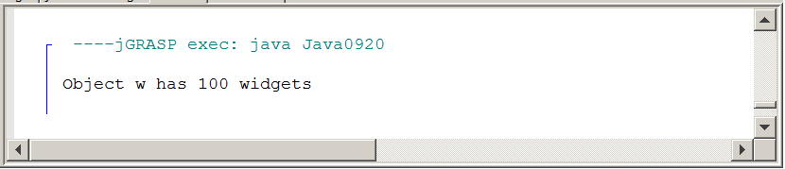
There is a way to make our same identifier people happy. Java has a special keyword called this. this is a reference and stores a memory value. Specifically, this stores the reference value of the current object in use. Java0921.java, in figure 9.25, has a second solution to the logic error of program Java0919.java.

The statement this.numWidgets = numWidgets now makes perfect sense to Java. The first numWidgets is the attribute of the object being called, which in this case is being constructed. Java knows this (normal English this) because this has the same reference as object w.

In method getWidgets the this reference is also used, but in that case it is optional. There is no possible confusion for Java. Inside method getWidgets is no definition of numWidgets. To Java this means that the attribute numWidgets, which has scope in the entire class is the intended variable. Technically, numWidgets has scope everywhere in class Widget, but the local declaration of numWidgets in the constructor has priority over the global class definition.

Figure 9.25
// Java0921.java
// Using the <this> reference is a second solution to the
// problem in program Java0919.java.

public class Java0921
{
public static void main(String[ ] args)
{
Widget w = new Widget(100);
System.out.println("Object w has " + w.getWidgets() + " widgets");
}
}

class Widget
{
private int numWidgets;

public Widget(int numWidgets)
{
this.numWidgets = numWidgets; // required use of this
}

public int getWidgets()
{
return this.numWidgets; // optional use of this
}
}

Figure 9.25 Continued
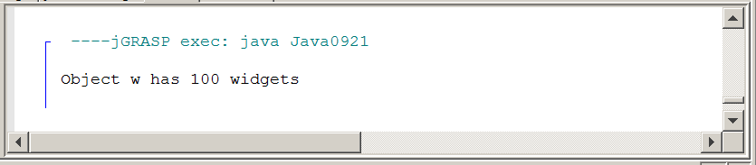

The proper use of this is very important in encapsulation. If it is not quite clear yet what exactly this references, look at program Java0922.java, in figure 9.26. In this program you will three objects of the Widget class instantiated. In each case the value of the object is displayed. Since objects store a memory reference to the location where the data is stored, the output becomes a memory location. Java usually starts with the name of the class followed by the memory address.

There is also a println statement inside the constructor of the Widget class and the value printed is this. Look closely at the output. You will first see the value of this, followed by the value of w1, then w2 and finally w3. Three different memory locations will be shown for each one of the Widget objects. In each case the memory location is the same as the current object in context. In other words when I am working with w1 then this has the same value as w1. Likewise when new memory is allocated for w2 you will see that this also gets this new address.

Figure 9.26
// Java0922.java
// Comparing the value of the three <Widget> objects demonstrates
// that the <this> reference value is equal to the current object used.

public class Java0922
{
public static void main(String[ ] args)
{
Widget w1 = new Widget(100);
System.out.println("w1 value: " + w1);
System.out.println();
Widget w2 = new Widget(100);
System.out.println("w2 value: " + w2);
System.out.println();
Widget w3 = new Widget(100);
System.out.println("w3 value: " + w3);
System.out.println();
}
}

class Widget
{
private int numWidgets;

public Widget(int numWidgets)
{
this.numWidgets = numWidgets;
System.out.println("this value: " + this);
}
}

Figure 9.26 Continued
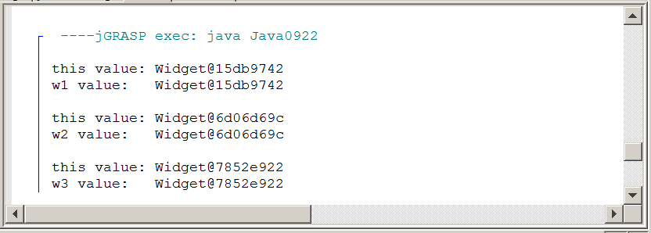

this reference
this references the object in context. This means that in a statement, such as tom.makeDeposit(1000), the reference address stored by tom will be identical to this when used inside the makeDeposit method.

9.8 Method Summary

The primary focus of this chapter was on creating object methods as opposed to creating class methods introduced in the last chapter. By now you have already seen an amazing number of different methods. In an effort to clarify all these methods, this chapter will conclude with a review of each type of method. Each method will be briefly explained and then an example of such a method is shown to review the precise Java syntax that is required.

Class or Static Methods

A class method calls the class directly, not an object of the class. This is practical when there is no need to make multiple copies of a data attributes. One example is Java’s Math class. Everybody can use the methods of the Math class and there is no need to construct multiple objects. The value of PI will be same with everybody using this class. Use the reserved word static at the start of a method heading to indicate that the method is a class method. In figure 9.27 notice how each method in the Piggy class is called by using the class identifier Piggy.

Figure 9.27
public class Demo
{
public static void main(String[ ] args)
{
Piggy.initData();
Piggy.showData();
Piggy.addData(1200);
Piggy.showData();
}
}

class Piggy
{
public static double savings;
public static void initData() { savings = 0; }
public static void addData(double s) { savings += s; }
public static void showData() { System.out.println("Savings: " + savings); }
}

Object or Non-Static Methods

Object methods are meant for those situations where multiple copies of an object must be constructed. The essence of the method does not change. What really changes is the fact that now an object must be constructed first with the new operator, and then the method can be called. In contrast to the class methods, object methods are called by using the object identifier. In the example below, the same Piggy class is used, with the same methods. Now the methods do not use the static keyword and figure 9.28 shows that any object must be called with an object identifier, like tom.

Figure 9.28
public class Demo
{
public static void main(String[ ] args)
{
Piggy tom = new Piggy();
tom.initData();
tom.showData();
tom.addData(1200);
tom.showData();
}
}

class Piggy
{
private double savings;

public void initData()
{
savings = 0;
}

public void addData(double s)
{
savings += s;
}

public void showData()
{
System.out.println("Savings: " + savings);
}
}

Public Methods

A public method can be accessed by members of the same class, and more importantly public methods can be accessed by any client of the class. The majority of methods are public. Method getCard, in figure 9.29 is public.

Figure 9.29
public int getRank()
{
return rank;
}

Void Methods

There are many ways to classify methods. Methods are not just public only, or private only, or static only, or anything else only. You, personally, have many classifications at the same time. You can be a Sophomore, Junior or Senior. At the same time you can be Male or Female. You can also belong to a religious group and you can be Catholic, Muslim, Jewish, Protestant or non-denominational or no religion at all. Classification also can be based on school organizations. You can be a band member, cheerleader, football player, gymnast, soccer player, academic decathlon member, etc. The point is do not be surprised if you see that a method shows up in many different classifications. The method in figure 9.30 is a public method, but for the purpose of this classification we are interested in the fact that it is a void method. Void methods do not return a value and use the reserved word void to indicate that no value will be returned.

Figure 9.30
public void showData()
{
System.out.println("Name: " + name);
System.out.println("Savings: " + savings);
}

Return Methods

Return methods are methods that return a value. Two features are necessary for a return method, and look for them in figure 9.31. First, you will see that the method heading indicates a data type, which is the type that the method returns. Second, you see a return statement in the method body.

Figure 9.31
public double getSavings()
{
return savings;
}

Default Constructor Methods

A constructor is a special method that is automatically called during the instantiation of a new object. If no visible constructor is provided Java will provide its own constructor, called a default constructor. A no-parameter constructor is also called a default constructor, like the example shown in figure 9.32. Constructors should always be public and they are special methods that are neither void nor return methods.

Figure 9.32
public Card()
{
suit = "Clubs";
rank = "Two";
pointValue = 2;
}

Overloaded Constructor Methods

An overloaded constructor is a second, third or more constructor that allows a new object to be instantiated according to some specifications that are passed by parameters. Figure 9.33 shows an overloaded Card constructor, which enters suit, rank and pointValue information.
Figure 9.33
public Card(String s, String r, int pV)
{
suit = s;
rank = r;
pointValue = pV;
}

Accessing or Get Methods

Methods that only access object data without altering the data are access methods or frequently called get methods. Frequently, access methods are return methods, which return object private data information. The example in figure 9.34 returns the value of suit.

Figure 9.34
public int getSuit()
{
return suit;
}

Altering or Modifier or Mutator or Set Methods

Altering methods are sometimes also called modifier methods or mutator methods or set methods. These are methods that not only access the private data of an object; they also alter the value of the data. The example in figure 9.35 accesses the savings attribute and adds the value of s to it.

Figure 9.35
public void savingsDeposit(double s)
{
savings += s;
}

This chapter served a dual purpose. First, it was a focus on Object Oriented Programming encapsulation. Second, it demonstrated how to create classes and object methods.

The primary objective of OOP is reliability. In the first of the “focus on OOP” chapters, encapsulation is explained. Encapsulation is the process whereby all the data, often called attributes, and the methods that process the date are placed - or encapsulated - in the same class container.

Reliability is furthermore increased by making the attributes private, which limits access to local attributes to local members of the same class only.

A special method, with the same name as the class, is called a constructor. The constructor is automatically called when a new object is instantiated. If the constructor has no parameters it is called a default constructor. Most classes have a second or third overloaded constructor with parameters.

Attributes are meant to be accessed only by members of the same class. This security is achieved by declaring attributes private. Methods that communicate with program code from outside the class are declared public. Methods in the same class as private attributes have access to the private data.

Methods that return a value are often called get methods. Methods that alter data attribute values are often called set methods or mutator methods.

The scope of a variable is the area of a class where the variable can be accessed. If two variables of the same name, also have the same scope, the program will not compile and indicate that there is a duplicate identifier.

Consider the following method:

public void display(int max)
{
for (int k = 1; k <= max; k++)
{
System.out.print(k + " ");
}
System.out.println("\n\n");
for (int k = max; k >= 1; k--)
{
System.out.print(k + " ");
}
System.out.println("\n\n");
}

In the code shown above variable k is used twice, but each time it is in its own for loop control structure. These are separate scope areas and the syntax is correct.
It is easy to cause problems with attribute identifiers and parameter identifiers. The class below shows one example of concern.

class Widget
{
private int numWidgets;

public Widget(int numWidgets)
{
numWidgets = numWidgets; // problem
}

public int getWidgets()
{
return numWidgets;
}
}

Identifier numWidgets is used twice and the local variable in the constructor has priority. The result is that the attribute receives no value and becomes zero. The problem is solved by using the this reference to indicate the attribute variable as you see demonstrated below.

class Widget
{
private int numWidgets;

public Widget(int numWidgets)
{
this.numWidgets = numWidgets; no problem
}

public int getWidgets()
{
return numWidgets;
}
}

